**CHAITHRA R**

AWS Cloud Engineer

 chaithraabhi779@gmail.com 7795699896  Bangalore Portfolio:chaithra.vercel.app

# Profile

Hardworking and passionate job seeker with strong organizational skills eager to secure entry-level AWS Devops position. Ready to help team achieve company goals.

# Professional Experience

*Veup Technology* **Linux and Aws:**

Hands on experience in Installing, Troubleshooting, Configuring, Maintenance and Support of Linux.

Experienced in Creation and managing user accounts, security rights, disk space and process monitoring in Linux.

Hands on experience in Linux commands and services

Managing and troubleshooting Aws Cloud platform and its features which includes EC2 to deploy virtual instances, elastic IP for public IP needs, Network interfaces for network connectivity,

AMI – creating custom images and template for easy deployment purpose. Setting up the Application Load Balancer with Auto-scaling Groups' maintaining the Dynamic Scaling Policy wrt to CPU Utilization.

During the POC, resolved multiple issues with PEM & PPK Key Pair files.

Hands-on with S3 bucket managing with instances.

Extensively worked on Security Groups Inbound and Outbound rules with all the mandatory Port #s.

Knowledge of Public, Private and Elastic IPs.

Designed the Route Table, Internet Gateway, NACL, and Security Groups.

Knowledge of Regions, AZs

Extended the EBS Storage capacity and mounted the volume. worked on architecting VPC on AWS with various components like EC2, LB, Auto Scaling etc., **Devops**

Regular cleanup activities to keep the environment healthy. Knowledge version control system tools like GIT and GITHUB Used Maven to build the source code.

Created build scripts using Maven to perform builds.

Defining the Git Branching Strategy to maintain quality products in Delivery.

Used Jenkins as a continuous integration tool.

Knowledge on SonarQube for source code quality and security vulnerabilities.

Creating CI/CD pipeline.

Configuration Management - Using Ansible tool to perform configuration, Deployment, Maintenance and other repetitive tasks.

Good Communication skills and Passionate, innovative towards the technology. Good Team spirit and good leadership qualities **POC Project:**

Hosting web application and database servers using Aws Ec2 and RDS service and placed web applications into load balancer by integrating autoscaling service for auto instance placement based on requirement.

Created VPC network to host web application and also used NAT Gateway to connect to the private subnet.

Hosted web application using server less compute option Lambda and DynamoDB. Used API gateway for application to lambda service connectivity.

**Technical skills**

Operating Systems: **Linux, Windows.** Version Control Tools: **GIT, GITHUB.**

Build Management Tools: **Maven.**

Scripting Languages: **Shell/Bash Scripting,**

Application Servers: **Apache tomcat, WordPress, OrangeHRM**.

Continuous Integration Tools: **Jenkins**

Web Server: **Apache HTTP**

Cloud Provider: **AWS**

# Skills

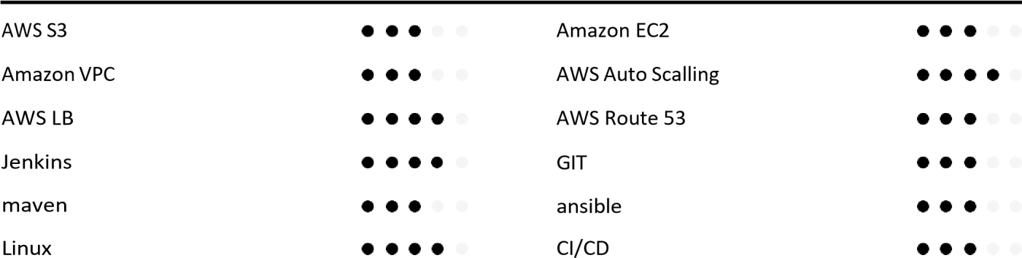

# Education

**B.tech Engineering (2017) [CGPA – 7.415],** *SJCIT,CHIKABALAPURE KARNATAKA*

**Diploma (2014)**  [85.5%] CHINHAMANI,CHIKKABALAPURE,KARNATAKA NEW GOVERNAMENT HIGH SCHOOL CHINTHAMANI.

CERTIFICATES:

* Done cloud computing course in Besant Technology

**Working Experience:**

* Worked in Teleperformance as a Customer support executive(client:Axis bank) for a year.
* Currently Working as server administrator in Veup Technologies PVT Ltd past one year.

# Declaration

I hereby declare the above

furnished information is true to my knowledge.

**CHAITHRA R**

## BANGALORE, 20/20/2023